**Capstone Project**

**Email Marketing Campaign**

The file **CampaignData_full.csv** has been copied to hdfs, using the hadoop fs –copyFromLocal command.

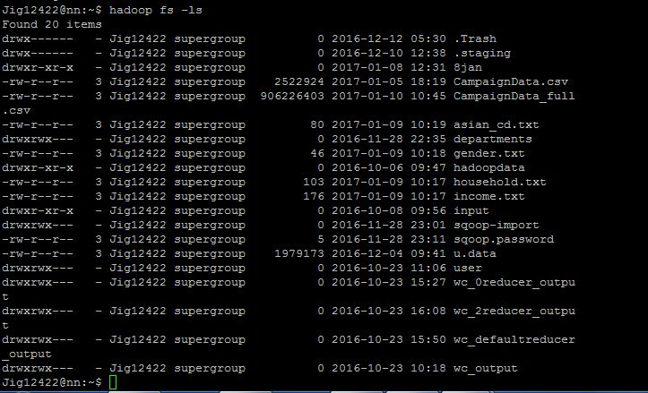

**Pig Latin Scripts**

grunt> register /home/data/piggybank.jar ;

grunt> define CSVLoader org.apache.pig.piggybank.storage.CSVLoader();

grunt> TEmailCampaignData_full = LOAD 'CampaignData_full.csv' USING CSVLoader AS (CLICK_FLG:chararray, OPEN_FLG:chararray, ADDR_VER_CD:chararray, AQI:chararray, ASIAN_CD:chararray, AUTO_IN_MARKET:chararray, BIRD_QTY:chararray, BUYER_DM_BOOKS:chararray, BUYER_DM_COLLECT_SPC_FOOD:chararray, BUYER_DM_CRAFTS_HOBBI:chararray, BUYER_DM_FEMALE_ORIEN:chararray, BUYER_DM_GARDEN_FARM:chararray, BUYER_DM_GENERAL:chararray, BUYER_DM_GIFT_GADGET:chararray, BUYER_DM_MALE_ORIEN:chararray, BUYER_DM_UPSCALE:chararray, BUYER_MAG_CULINARY_INTERS:chararray, BUYER_MAG_FAMILY_GENERAL:chararray, BUYER_MAG_FEMALE_ORIENTED:chararray, BUYER_MAG_GARDEN_FARMING:chararray, BUYER_MAG_HEALTH_FITNESS:chararray, BUYER_MAG_MALE_SPORT_ORIENTED:chararray, BUYER_MAG_RELIGIOUS:chararray, CATS_QTY:chararray, CEN_2000_MATCH_LEVEL:chararray, CLUB_MEMBER_CD:chararray, COUNTRY_OF_ORIGIN:chararray, DECEASED_INDICATOR:chararray, DM_RESPONDER_HH:chararray, DM_RESPONDER_INDIV:chararray, DMR_CONTRIB_CAT_GENERAL:chararray, DMR_CONTRIB_CAT_HEALTH_INST:chararray, DMR_CONTRIB_CAT_POLITICAL:chararray, DMR_CONTRIB_CAT_RELIGIOUS:chararray, DMR_DO_IT_YOURSELFERS:chararray, DMR_MISCELLANEOUS:chararray, DMR_NEWS_FINANCIAL:chararray, DMR_ODD_ENDS:chararray, DMR_PHOTOGRAPHY:chararray, DMR_SWEEPSTAKES:chararray, DOG_QTY:chararray, DWELLING_TYPE:chararray, DWELLING_UNIT_SIZE:chararray, EST_LOAN_VALUE_RATIO:chararray, ETECH_GROUP:chararray, ETHNIC_GROUP_CODE:chararray, ETHNIC_INSIGHT_MTCH_FLG:chararray, ETHNICITY_DETAIL:chararray, EXPERIAN_INCOME_CD:chararray, EXPERIAN_INCOME_CD_V4:chararray, GNDR_OF_CHLDRN_0_3:chararray, GNDR_OF_CHLDRN_10_12:chararray, GNDR_OF_CHLDRN_13_18:chararray, GNDR_OF_CHLDRN_4_6:chararray, GNDR_OF_CHLDRN_7_9:chararray, HH_INCOME:chararray, HHLD_DM_PURC_CD:chararray, HOME_BUSINESS_IND:chararray, I1_BUSINESS_OWNER_FLG:chararray, I1_EXACT_AGE:chararray, I1_GNDR_CODE:chararray, I1_INDIV_HHLD_STATUS_CODE:chararray, INDIV_EDUCATION:chararray, INDIV_EDUCATION_CONF_LVL:chararray, INDIV_MARITAL_STATUS:chararray, INDIV_MARITAL_STATUS_CONF_LVL:chararray, INS_MATCH_TYPE:chararray, LANGUAGE:chararray, LENGTH_OF_RESIDENCE:chararray, MEDIAN_HOUSING_VALUE:chararray, MEDIAN_LEN_OF_RESIDENCE:chararray, MM_INCOME_CD:chararray, MOSAIC_HH:chararray, MULTI_BUYER_INDIV:chararray, NEW_CAR_MODEL:chararray, NUM_OF_ADULTS_IN_HHLD:chararray, NUMBER_OF_CHLDRN_18_OR_LESS:chararray, OCCUP_DETAIL:chararray, OCCUP_MIX_PCT:chararray, PCT_CHLDRN:chararray, PCT_DEROG_TRADES:chararray, PCT_HOUSEHOLDS_BLACK:chararray, PCT_OWNER_OCCUPIED:chararray, PCT_RENTER_OCCUPIED:chararray, PCT_TRADES_NOT_DEROG:chararray, PCT_WHITE:chararray, PHONE_TYPE_CD:chararray, PRES_OF_CHLDRN_0_3:chararray, PRES_OF_CHLDRN_10_12:chararray, PRES_OF_CHLDRN_13_18:chararray, PRES_OF_CHLDRN_4_6:chararray, PRES_OF_CHLDRN_7_9:chararray, PRESENCE_OF_CHLDRN:chararray, PRIM_FEM_EDUC_CD:chararray, PRIM_FEM_OCC_CD:chararray, PRIM_MALE_EDUC_CD:chararray, PRIM_MALE_OCC_CD:chararray, RECIPIENT_RELIABILITY_CD:chararray, RELIGION:chararray, SCS_MATCH_TYPE:chararray, TRW_INCOME_CD:chararray, TRW_INCOME_CD_V4:chararray, USED_CAR_CD:chararray, Y_OWNS_HOME:chararray, Y_PROBABLE_HOMEOWNER:chararray, Y_PROBABLE_RENTER:chararray, Y_RENTER:chararray, YRS_SCHOOLING_CD:chararray, Z_CREDIT_CARD:chararray, age_hh_mem1:chararray, age_hh_mem2:chararray, age_hh_mem3:chararray, age_hh_mem4:chararray, age_hh_mem5:chararray, age_hh_mem6:chararray, age_hh_mem7:chararray, age_hh_mem8:chararray, gender_hh_mem1:chararray, gender_hh_mem2:chararray, gender_hh_mem3:chararray, gender_hh_mem4:chararray, gender_hh_mem5:chararray, gender_hh_mem6:chararray, gender_hh_mem7:chararray, gender_hh_mem8:chararray, statcd_hh_mem1:chararray, statcd_hh_mem2:chararray, statcd_hh_mem3:chararray, statcd_hh_mem4:chararray, statcd_hh_mem5:chararray, statcd_hh_mem6:chararray, statcd_hh_mem7:chararray, statcd_hh_mem8:chararray, trait_cd1:chararray, trait_cd2:chararray, trait_cd3:chararray, trait_cd4:chararray, trait_cd5:chararray, trait_cd6:chararray, trait_cd7:chararray, trait_cd8:chararray, trait_cd9:chararray, trait_cd10:chararray, trait_cd11:chararray, trait_cd12:chararray, trait_cd13:chararray, trait_cd14:chararray, trait_cd15:chararray, trait_cd16:chararray, trait_cd17:chararray, trait_cd18:chararray, trait_cd19:chararray, trait_cd20:chararray, trait_cd21:chararray, trait_cd22:chararray, trait_cd23:chararray, trait_cd24:chararray, trait_cd25:chararray, trait_cd26:chararray, trait_cd27:chararray, trait_cd28:chararray, trait_cd29:chararray, trait_cd30:chararray, trait_cd31:chararray, trait_cd32:chararray, trait_cd33:chararray, trait_cd34:chararray, trait_cd35:chararray, trait_cd36:chararray, trait_cd37:chararray, trait_cd38:chararray, trait_cd39:chararray, trait_cd40:chararray, trait_cd41:chararray, trait_cd42:chararray, trait_cd43:chararray, trait_cd44:chararray, trait_cd45:chararray, trait_cd46:chararray, trait_cd47:chararray, trait_cd48:chararray, trait_cd49:chararray, trait_cd50:chararray, trait_cd51:chararray, trait_cd52:chararray, trait_cd53:chararray, trait_cd54:chararray, trait_cd55:chararray, trait_cd56:chararray, trait_cd57:chararray, trait_cd58:chararray, trait_cd59:chararray, trait_cd60:chararray, trait_cd61:chararray, trait_cd62:chararray, trait_cd63:chararray, trait_cd64:chararray, trait_typ_cd1:chararray, trait_typ_cd2:chararray, trait_typ_cd3:chararray, trait_typ_cd4:chararray, trait_typ_cd5:chararray, trait_typ_cd6:chararray, trait_typ_cd7:chararray, trait_typ_cd8:chararray, trait_typ_cd9:chararray, trait_typ_cd10:chararray, trait_typ_cd11:chararray, trait_typ_cd12:chararray, trait_typ_cd13:chararray, trait_typ_cd14:chararray, trait_typ_cd15:chararray, trait_typ_cd16:chararray, trait_typ_cd17:chararray, trait_typ_cd18:chararray, trait_typ_cd19:chararray, trait_typ_cd20:chararray, trait_typ_cd21:chararray, trait_typ_cd22:chararray, trait_typ_cd23:chararray, trait_typ_cd24:chararray, trait_typ_cd25:chararray, trait_typ_cd26:chararray, trait_typ_cd27:chararray, trait_typ_cd28:chararray, trait_typ_cd29:chararray, trait_typ_cd30:chararray, trait_typ_cd31:chararray, trait_typ_cd32:chararray, trait_typ_cd33:chararray, trait_typ_cd34:chararray, trait_typ_cd35:chararray, trait_typ_cd36:chararray, trait_typ_cd37:chararray, trait_typ_cd38:chararray, trait_typ_cd39:chararray, trait_typ_cd40:chararray, trait_typ_cd41:chararray, trait_typ_cd42:chararray, trait_typ_cd43:chararray, trait_typ_cd44:chararray, trait_typ_cd45:chararray, trait_typ_cd46:chararray, trait_typ_cd47:chararray, trait_typ_cd48:chararray, trait_typ_cd49:chararray, trait_typ_cd50:chararray, trait_typ_cd51:chararray, trait_typ_cd52:chararray, trait_typ_cd53:chararray, trait_typ_cd54:chararray, trait_typ_cd55:chararray, trait_typ_cd56:chararray, trait_typ_cd57:chararray, trait_typ_cd58:chararray, trait_typ_cd59:chararray, trait_typ_cd60:chararray, trait_typ_cd61:chararray, trait_typ_cd62:chararray, trait_typ_cd63:chararray, trait_typ_cd64:chararray, CITY:chararray, POSTAL_CD:chararray, STATE_PROVINCE:chararray, new_id:chararray, list_auth_cd:chararray, list_auth_flg:chararray, new_list_id:chararray, list_new_brand_cd:chararray, list_new_ed_cd:chararray, new_mailing_id:chararray, Mailing_Category:chararray, Mailed_Date:chararray);

grunt> EmailCampaignData1 = FOREACH TEmailCampaignData_full generate CLICK_FLG as CLICK_FLG,OPEN_FLG as OPEN_FLG,ADDR_VER_CD as ADDR_VER_CD,AQI as AQI, (ASIAN_CD == '' ? 'null' : (ASIAN_CD is null ? 'null': ASIAN_CD)) as ASIAN_CD, AUTO_IN_MARKET as AUTO_IN_MARKET,BIRD_QTY as BIRD_QTY ,DM_RESPONDER_HH as DM_RESPONDER_HH, GNDR_OF_CHLDRN_0_3 as GNDR_OF_CHLDRN_0_3 ,GNDR_OF_CHLDRN_10_12 as GNDR_OF_CHLDRN_10_12,GNDR_OF_CHLDRN_13_18 as GNDR_OF_CHLDRN_13_18,GNDR_OF_CHLDRN_4_6 as GNDR_OF_CHLDRN_4_6,GNDR_OF_CHLDRN_7_9 as GNDR_OF_CHLDRN_7_9 ,HOME_BUSINESS_IND as HOME_BUSINESS_IND,I1_BUSINESS_OWNER_FLG as I1_BUSINESS_OWNER_FLG ,I1_EXACT_AGE as I1_EXACT_AGE,I1_GNDR_CODE as I1_GNDR_CODE, (I1_INDIV_HHLD_STATUS_CODE == '' ? 'null' : I1_INDIV_HHLD_STATUS_CODE) as I1_INDIV_HHLD_STATUS_CODE,INDIV_MARITAL_STATUS as INDIV_MARITAL_STATUS,LANGUAGE as LANGUAGE,MM_INCOME_CD as MM_INCOME_CD,NUM_OF_ADULTS_IN_HHLD as NUM_OF_ADULTS_IN_HHLD,NUMBER_OF_CHLDRN_18_OR_LESS as NUMBER_OF_CHLDRN_18_OR_LESS,PRES_OF_CHLDRN_0_3 as PRES_OF_CHLDRN_0_3,PRES_OF_CHLDRN_10_12 as PRES_OF_CHLDRN_10_12, PRES_OF_CHLDRN_13_18 as PRES_OF_CHLDRN_13_18,PRES_OF_CHLDRN_4_6 as PRES_OF_CHLDRN_4_6,PRES_OF_CHLDRN_7_9 as PRES_OF_CHLDRN_7_9,PRESENCE_OF_CHLDRN as PRESENCE_OF_CHLDRN,RELIGION as RELIGION,age_hh_mem1 as age_hh_mem1,age_hh_mem2 as age_hh_mem2,age_hh_mem3 as age_hh_mem3, age_hh_mem4 as age_hh_mem4,age_hh_mem5 as age_hh_mem5,age_hh_mem6 as age_hh_mem6,age_hh_mem7 as age_hh_mem7,age_hh_mem8 as age_hh_mem8,gender_hh_mem1 as gender_hh_mem1, gender_hh_mem2 as gender_hh_mem2, gender_hh_mem3 as gender_hh_mem3,gender_hh_mem4 as gender_hh_mem4,gender_hh_mem5 as gender_hh_mem5,gender_hh_mem6 as gender_hh_mem6,gender_hh_mem7 as gender_hh_mem7,gender_hh_mem8 as gender_hh_mem8,statcd_hh_mem1 as statcd_hh_mem1,statcd_hh_mem2 as statcd_hh_mem2,statcd_hh_mem3 as statcd_hh_mem3,statcd_hh_mem4 as statcd_hh_mem4,statcd_hh_mem5 as statcd_hh_mem5,statcd_hh_mem6 as statcd_hh_mem6,statcd_hh_mem7 as statcd_hh_mem7,statcd_hh_mem8 as statcd_hh_mem8,CITY as CITY,new_id as new_id,new_list_id as new_list_id,new_mailing_id as new_mailing_id,Mailing_Category as Mailing_Category, (TRW_INCOME_CD_V4 == '' ? 'null' : TRW_INCOME_CD_V4) as TRW_INCOME_CD_V4, Mailed_Date as Mailed_Date, SUBSTRING(Mailed_Date,5,13) As Date,CONCAT('20',SUBSTRING(Mailed_Date,11,13)) As Year,(SUBSTRING(Mailed_Date,5,7)=='01' ? 'January' : ( SUBSTRING(Mailed_Date,5,7)=='02' ? 'February' : (SUBSTRING(Mailed_Date,5,7)=='03' ? 'March' :(SUBSTRING(Mailed_Date,5,7)=='04' ? 'April' :(SUBSTRING(Mailed_Date,5,7)=='05' ? 'May' :(SUBSTRING(Mailed_Date,5,7)=='06' ? 'June' :(SUBSTRING(Mailed_Date,5,7)=='07' ? 'July' :(SUBSTRING(Mailed_Date,5,7)=='08' ? 'August' :(SUBSTRING(Mailed_Date,5,7)=='09' ? 'September' :(SUBSTRING(Mailed_Date,5,7)=='10' ? 'October' :(SUBSTRING(Mailed_Date,5,7)=='11' ? 'November' :'December'))))))))))) As Month,SUBSTRING(Mailed_Date,0,3) as Day,SUBSTRING(Mailed_Date,14,19) as TimeStamp,SUBSTRING(Mailed_Date,20,22) as AMPM;

grunt> IncomeHouseHold = LOAD 'income.txt' USING PigStorage('|') as (group:chararray,income:chararray);

grunt> AsianEthnicity = LOAD 'asian_cd.txt' USING PigStorage('|') as (ethnicitycode:chararray,ethnicity:chararray);

grunt> HouseHoldStatus = LOAD 'household.txt ' USING PigStorage('|') as (statuscode:chararray,status:chararray);

grunt> Gender = LOAD 'gender.txt ' USING PigStorage('|') as (gendercode:chararray,genderdesc:chararray);

grunt> Join1 = JOIN EmailCampaignData1 BY TRW_INCOME_CD_V4 , IncomeHouseHold BY group;

grunt> Join2 = JOIN Join1 BY EmailCampaignData1::ASIAN_CD , AsianEthnicity BY ethnicitycode;

grunt> Join3 = JOIN Join2 BY Join1::EmailCampaignData1::I1_INDIV_HHLD_STATUS_CODE , HouseHoldStatus BY statuscode;

grunt> Join4 = JOIN Join3 BY Join1::EmailCampaignData1::I1_GNDR_CODE, Gender BY gendercode;

grunt> STORE Join4 INTO 'emc/EmailMarketingCampaign_full/' USING PigStorage('|');

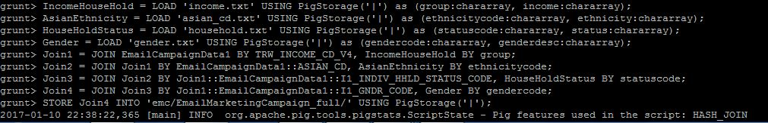

**The below screenshot shows that the Map Reduce job in Pig Latin has run successfully. The output of the job is stored at /user/Jig12422/emc/EmailMarketingCampaign_full.**

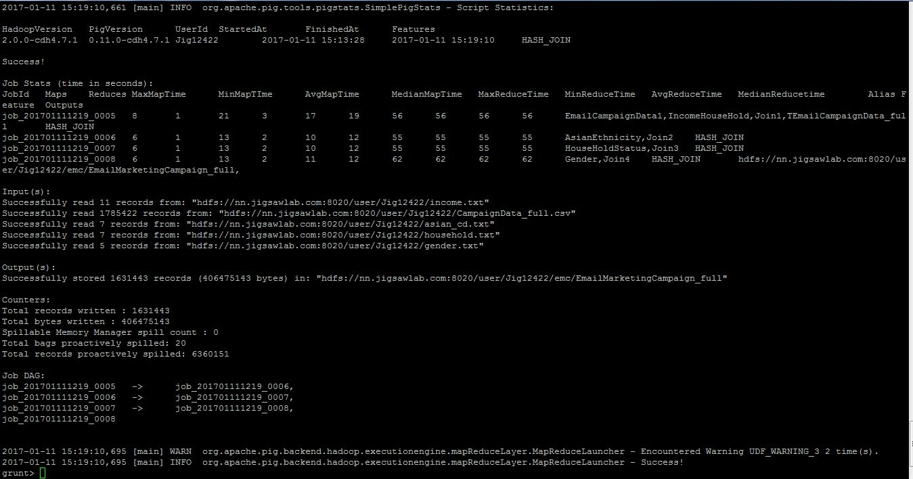

**CONTENTS OF ‘asian_cd.txt’ FILE:**

00|Unknown

05|Chinese

24|Japanese

25|Korean

47|Vietnamese

48|Asian

null|No match

**CONTENTS OF ‘gender.txt’ FILE:**

B|Both

F|Female

M|Male

U|Unknown

null|no match

**CONTENTS OF ‘household.txt’ FILE:**

D|Deceased

H|Head

P|Aged parent living home

U|Unknown

W|Spouse

Y|Young adult (Age 19-25)

null|No match

**CONTENTS OF ‘income.txt’ FILE:**

J|<$15,000

K|$15,000-$24,999

L|$25,000-$34,999

M|$35,000-$49,999

N|$50,000-$74,999

O|$75,000-$99,999

P|$100,000-$119,999

Q|$120,000-$149,999

R|$150,000+

U|Unknown

null|No match

**Hive DDL & DML**

hive> CREATE DATABASE Capstone;

hive> Use Capstone;

hive> CREATE EXTERNAL TABLE emchive(CLICK_FLG string,OPEN_FLG string,ADDR_VER_CD string,AQI string,ASIAN_CD string,AUTO_IN_MARKET string,BIRD_QTY string,DM_RESPONDER_HH string,GNDR_OF_CHLDRN_0_3 string,GNDR_OF_CHLDRN_10_12 string,GNDR_OF_CHLDRN_13_18 string,GNDR_OF_CHLDRN_4_6 string,GNDR_OF_CHLDRN_7_9 string,HOME_BUSINESS_IND string,I1_BUSINESS_OWNER_FLG string,I1_EXACT_AGE string,I1_GNDR_CODE string,I1_INDIV_HHLD_STATUS_CODE string,INDIV_MARITAL_STATUS string,LANGUAGE string,MM_INCOME_CD string,NUM_OF_ADULTS_IN_HHLD string,NUMBER_OF_CHLDRN_18_OR_LESS string,PRES_OF_CHLDRN_0_3 string,PRES_OF_CHLDRN_10_12 string,PRES_OF_CHLDRN_13_18 string,PRES_OF_CHLDRN_4_6 string,PRES_OF_CHLDRN_7_9 string,PRESENCE_OF_CHLDRN string,RELIGION string,age_hh_mem1 string,age_hh_mem2 string,age_hh_mem3 string,age_hh_mem4 string,age_hh_mem5 string,age_hh_mem6 string,age_hh_mem7 string,age_hh_mem8 string,gender_hh_mem1 string,gender_hh_mem2 string,gender_hh_mem3 string,gender_hh_mem4 string,gender_hh_mem5 string,gender_hh_mem6 string,gender_hh_mem7 string,gender_hh_mem8 string,statcd_hh_mem1 string,statcd_hh_mem2 string,statcd_hh_mem3 string,statcd_hh_mem4 string,statcd_hh_mem5 string,statcd_hh_mem6 string,statcd_hh_mem7 string,statcd_hh_mem8 string,CITY string,new_id string,new_list_id string,new_mailing_id string,Mailing_Category string,TRW_INCOME_CD_V4 string,Mailed_Date string,datepart string, Mail_Year string,Mail_Month string,Mail_Day string,Mail_TimeStamp string, AMPM string, income_group string, income string,ethnicitycode string, ethnicity string, hhstatuscode string, hhstatus string, gendercode string, gender string) ROW FORMAT DELIMITED

FIELDS TERMINATED BY '|'

LOCATION '/user/Jig12422/emc/EmailMarketingCampaign_full';

**Codes for solving question set 1**

**1A. Overall CTOR**

hive> SELECT ROUND(SUM(CASE WHEN CLICK_FLG = 'Y' THEN 1 ELSE 0 END)/count(*) * 100,2) CTOR FROM emchive WHERE OPEN_FLG = 'Y';

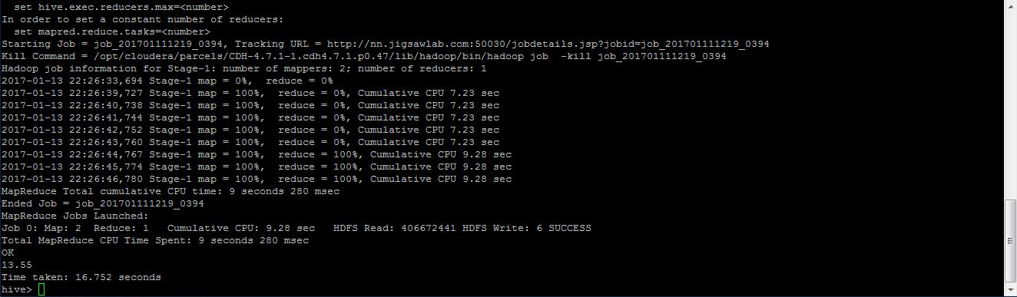

hive> CREATE TABLE CTOR as SELECT ROUND(SUM(CASE WHEN CLICK_FLG = 'Y' THEN 1 ELSE 0 END)/count(*) * 100,2) CTOR FROM emchive WHERE OPEN_FLG = 'Y';

**1B. CTOR by Gender**

hive> SELECT gender, ROUND(SUM(CASE WHEN CLICK_FLG = 'Y' THEN 1 ELSE 0 END)/count(*) * 100,2) CTOR FROM emchive WHERE OPEN_FLG ='Y' GROUP BY gender;

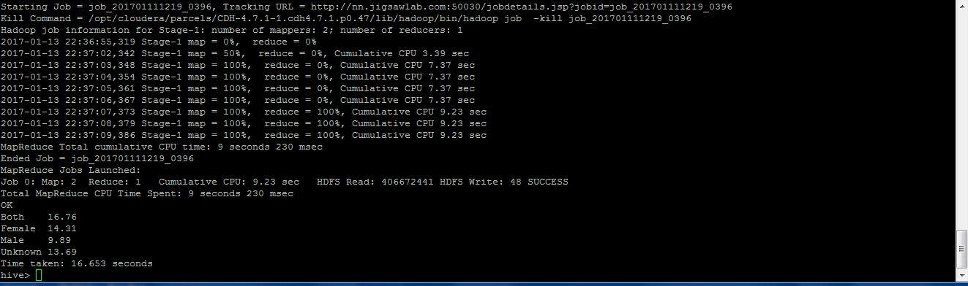

hive> CREATE TABLE CTOR_Gender as SELECT gender, ROUND(SUM(CASE WHEN CLICK_FLG = 'Y' THEN 1 ELSE 0 END)/count(*) * 100,2) CTOR FROM emchive WHERE OPEN_FLG ='Y' GROUP BY gender;

**1C. CTOR by Time of the day**

hive> SELECT Mail_TimeStamp, ROUND(SUM(CASE WHEN CLICK_FLG = 'Y' THEN 1 ELSE 0 END)/count(*) * 100,2) CTOR FROM emchive WHERE OPEN_FLG='Y' GROUP BY Mail_TimeStamp;

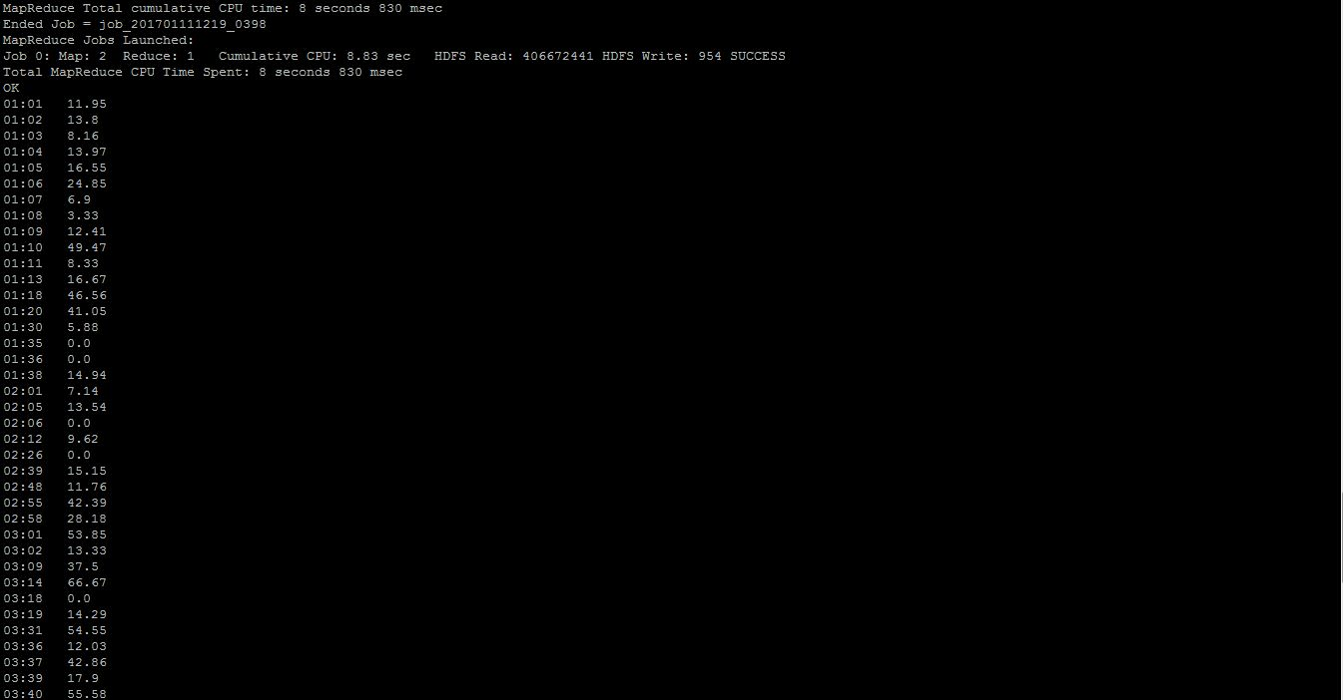

hive> CREATE TABLE CTOR_TimeOfDay as SELECT Mail_TimeStamp, ROUND(SUM(CASE WHEN CLICK_FLG = 'Y' THEN 1 ELSE 0 END)/count(*) * 100,2) CTOR FROM emchive WHERE OPEN_FLG='Y' GROUP BY Mail_TimeStamp;

**1D. CTOR by Day of the week.**

hive> SELECT Mail_Day, ROUND(SUM(CASE WHEN CLICK_FLG = 'Y' THEN 1 ELSE 0 END)/count(*) * 100,2) CTOR FROM emchive WHERE OPEN_FLG='Y' GROUP BY Mail_Day;

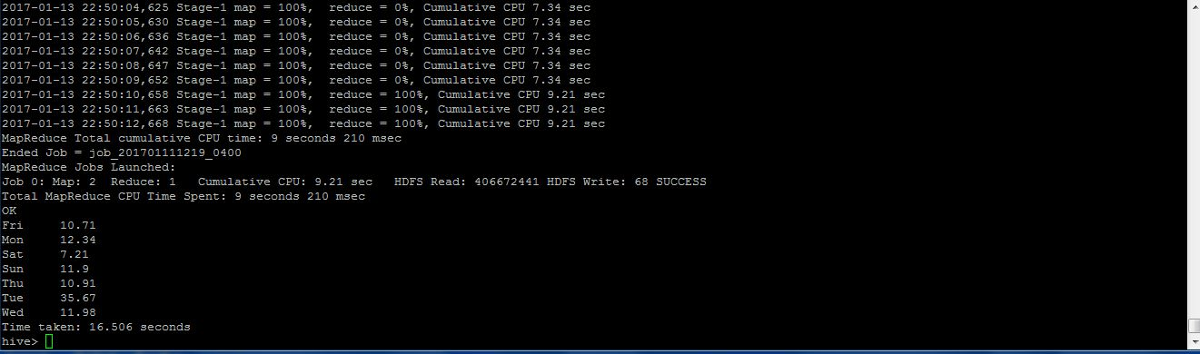

hive> CREATE TABLE CTOR_DayOfTheWeek as SELECT Mail_Day, ROUND(SUM(CASE WHEN CLICK_FLG = 'Y' THEN 1 ELSE 0 END)/count(*) * 100,2) CTOR FROM emchive WHERE OPEN_FLG='Y' GROUP BY Mail_Day;

**1E. CTOR by Month**

hive> SELECT Mail_Month, ROUND(SUM(CASE WHEN CLICK_FLG = 'Y' THEN 1 ELSE 0 END)/count(*) * 100,2) CTOR FROM emchive WHERE OPEN_FLG ='Y' GROUP BY Mail_Month;

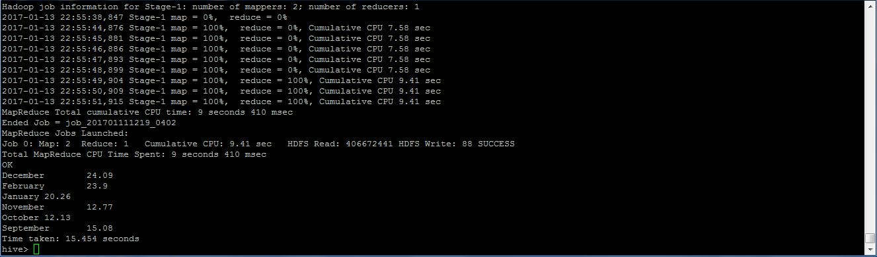

hive> CREATE TABLE CTOR_Month as SELECT Mail_Month, ROUND(SUM(CASE WHEN CLICK_FLG = 'Y' THEN 1 ELSE 0 END)/count(*) * 100,2) CTOR FROM emchive WHERE OPEN_FLG ='Y' GROUP BY Mail_Month;

**1F. CTOR by Lead's Income Group**

hive> SELECT TRW_INCOME_CD_V4, ROUND(SUM(CASE WHEN CLICK_FLG = 'Y' THEN 1 ELSE 0 END)/count(*) * 100,2) CTOR FROM emchive WHERE OPEN_FLG='Y' GROUP BY TRW_INCOME_CD_V4;

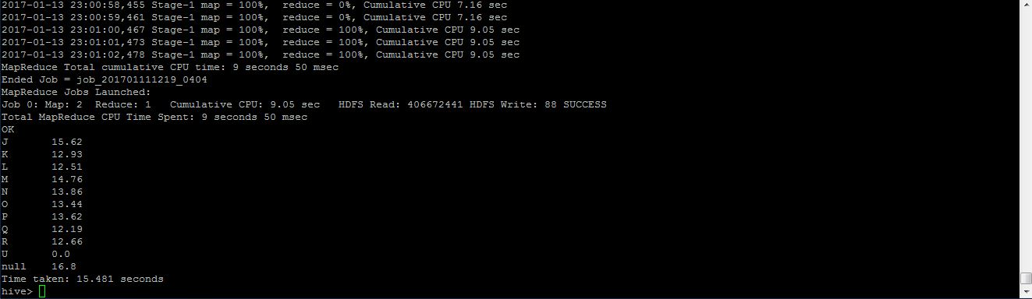

hive> CREATE TABLE CTOR_LeadsIncomeGroup as SELECT TRW_INCOME_CD_V4, ROUND(SUM(CASE WHEN CLICK_FLG = 'Y' THEN 1 ELSE 0 END)/count(*) * 100,2) CTOR FROM emchive WHERE OPEN_FLG='Y' GROUP BY TRW_INCOME_CD_V4;

**1G. CTOR by Lead's Ethnicity**

hive> SELECT ASIAN_CD, ROUND(SUM(CASE WHEN CLICK_FLG = 'Y' THEN 1 ELSE 0 END)/count(*) * 100,2) CTOR FROM emchive WHERE OPEN_FLG='Y' GROUP BY ASIAN_CD;

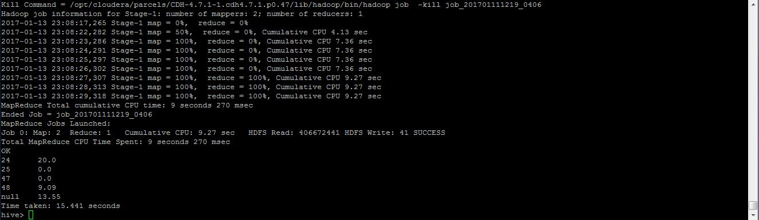

hive> CREATE TABLE CTOR_LeadsEthnicity as SELECT ASIAN_CD, ROUND(SUM(CASE WHEN CLICK_FLG = 'Y' THEN 1 ELSE 0 END)/count(*) * 100,2) CTOR FROM emchive WHERE OPEN_FLG='Y' GROUP BY ASIAN_CD;

**1H. CTOR by Lead's Household Status**

hive> SELECT I1_INDIV_HHLD_STATUS_CODE, ROUND(SUM(CASE WHEN CLICK_FLG = 'Y' THEN 1 ELSE 0 END)/count(*) * 100,2) CTOR FROM emchive WHERE OPEN_FLG='Y' GROUP BY I1_INDIV_HHLD_STATUS_CODE;

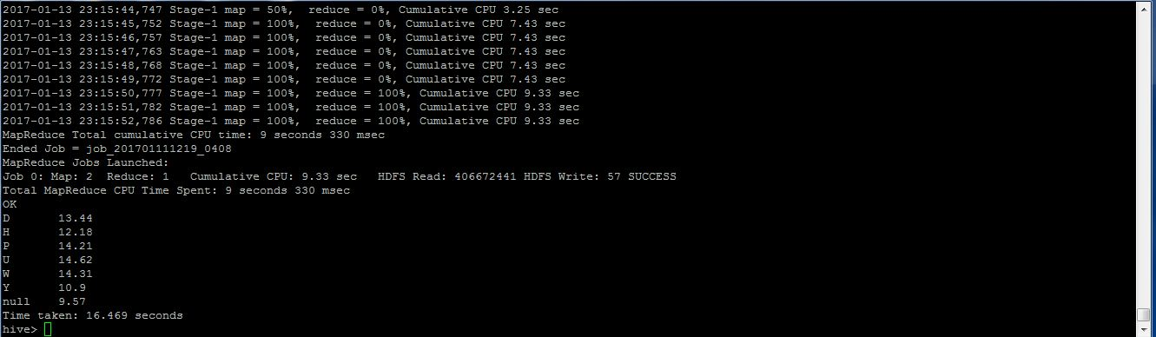

hive> CREATE TABLE CTOR_LeadsHouseHold as SELECT I1_INDIV_HHLD_STATUS_CODE, ROUND(SUM(CASE WHEN CLICK_FLG = 'Y' THEN 1 ELSE 0 END)/count(*) * 100,2) CTOR FROM emchive WHERE OPEN_FLG='Y' GROUP BY I1_INDIV_HHLD_STATUS_CODE;

**Note: First the Hive queries are run and their outputs have been taken as screenshots. Then, tables have been created with the same queries to store the output in hdfs for processing in Tableau.**

**Codes for solving question set 2**

**2. Household Members Information**

**A. Find count of leads with information about members of their household. If a lead has information about 3 members, and another has information about 2 members and another has none, then the answer to this question is 2. (use statcd_hh_mem - statcd_hh_mem8 column)**

hive> SELECT SUM(CASE WHEN statcd_hh_mem1 != "" OR statcd_hh_mem2 != "" OR statcd_hh_mem3 != "" OR statcd_hh_mem4 != "" OR statcd_hh_mem5 != "" OR statcd_hh_mem6 != "" OR statcd_hh_mem7 != "" OR statcd_hh_mem8 != "" THEN 1 ELSE 0 END) AS total FROM emchive;

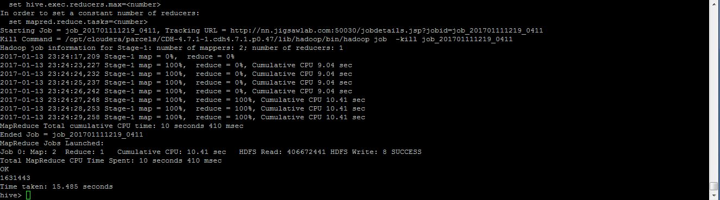

hive> CREATE TABLE 2A as SELECT SUM(CASE WHEN statcd_hh_mem1 != "" OR statcd_hh_mem2 != "" OR statcd_hh_mem3 != "" OR statcd_hh_mem4 != "" OR statcd_hh_mem5 != "" OR statcd_hh_mem6 != "" OR statcd_hh_mem7 != "" OR statcd_hh_mem8 != "" THEN 1 ELSE 0 END) AS total FROM emchive;

**2B. Find count of total number of household members information is available. For example, if a lead has 3 household members, and another has about 2 members, and the other has none, then the total count of household members is 3+2+0 = 5.**

hive> SELECT SUM(CASE WHEN statcd_hh_mem1 != "" THEN 1 ELSE 0 END) + SUM(CASE WHEN statcd_hh_mem2 != "" THEN 1 ELSE 0 END) + SUM(CASE WHEN statcd_hh_mem3 != "" THEN 1 ELSE 0 END) + SUM(CASE WHEN statcd_hh_mem4 != "" THEN 1 ELSE 0 END) + SUM(CASE WHEN statcd_hh_mem5 != "" THEN 1 ELSE 0 END) + SUM(CASE WHEN statcd_hh_mem6 != "" THEN 1 ELSE 0 END) + SUM(CASE WHEN statcd_hh_mem7 != "" THEN 1 ELSE 0 END) + SUM(CASE WHEN statcd_hh_mem8 != "" THEN 1 ELSE 0 END) AS total FROM emchive;

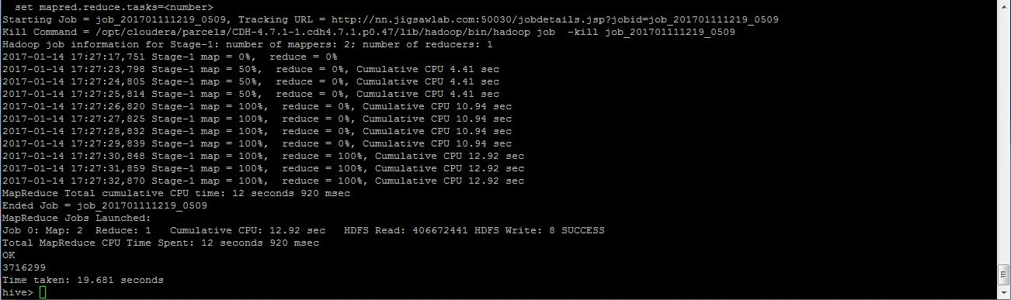

hive> CREATE TABLE 2B as SELECT SUM(CASE WHEN statcd_hh_mem1 != "" THEN 1 ELSE 0 END) + SUM(CASE WHEN statcd_hh_mem2 != "" THEN 1 ELSE 0 END) + SUM(CASE WHEN statcd_hh_mem3 != "" THEN 1 ELSE 0 END) + SUM(CASE WHEN statcd_hh_mem4 != "" THEN 1 ELSE 0 END) + SUM(CASE WHEN statcd_hh_mem5 != "" THEN 1 ELSE 0 END) + SUM(CASE WHEN statcd_hh_mem6 != "" THEN 1 ELSE 0 END) + SUM(CASE WHEN statcd_hh_mem7 != "" THEN 1 ELSE 0 END) + SUM(CASE WHEN statcd_hh_mem8 != "" THEN 1 ELSE 0 END) AS total FROM emchive;

**2C. Find count of household members by type (Head of Household, Spouse etc.).**

hive> select (case when member=''” then 'no match'

 when member='W' then 'Spouse'

 when member='U' then 'Unknown'

 when member='Y' then 'Young Adult'

 when member='H' then 'Head'

 when member='D' then 'deceased'

 when member='P' then 'Aged Parent Living Home' end), count(*) From (select statcd_hh_mem1 as member from emchive

union all

select statcd_hh_mem2 as member from emchive

union all

select statcd_hh_mem3 as member from emchive

union all

select statcd_hh_mem4 as member from emchive

union all

select statcd_hh_mem5 as member from emchive

union all

select statcd_hh_mem6 as member from emchive

union all

select statcd_hh_mem7 as member from emchive

union all

select statcd_hh_mem8 as member from emchive) myTab

group by member;

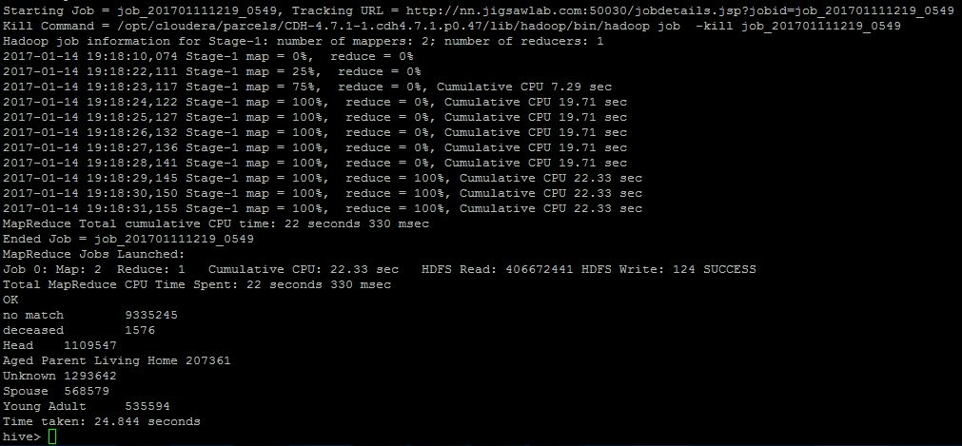

hive> CREATE TABLE 2C as select (case when member=''” then 'no match'

 when member='W' then 'Spouse'

 when member='U' then 'Unknown'

 when member='Y' then 'Young Adult'

 when member='H' then 'Head'

 when member='D' then 'deceased'

 when member='P' then 'Aged Parent Living Home' end), count(*) From (select statcd_hh_mem1 as member from emchive

union all

select statcd_hh_mem2 as member from emchive

union all

select statcd_hh_mem3 as member from emchive

union all

select statcd_hh_mem4 as member from emchive

union all

select statcd_hh_mem5 as member from emchive

union all

select statcd_hh_mem6 as member from emchive

union all

select statcd_hh_mem7 as member from emchive

union all

select statcd_hh_mem8 as member from emchive) myTab

group by member;

**2D. %age of household members type. For example, if there are 5 Head of Household, 10 Spouse and 85 in the other categories, then the %age of Spouses is 10.**

hive> CREATE EXTERNAL TABLE householdtype(hhtype  string, hhtypedesc string) ROW FORMAT DELIMITED

FIELDS TERMINATED BY '|';

hive> LOAD DATA INPATH    ‘household’  into table householdtype;

hive> CREATE VIEW vw_hhcount AS SELECT hh.hhtypedesc, typecount.hhcount FROM

(SELECT t.hhtype, count(1) hhcount FROM emchive LATERAL VIEW explode(array(statcd_hh_mem1, statcd_hh_mem2, statcd_hh_mem3, statcd_hh_mem4, statcd_hh_mem5, statcd_hh_mem6, statcd_hh_mem7, statcd_hh_mem8)) t AS hhtype WHERE t.hhtype != ''” GROUP BY t.hhtype) typecount JOIN householdtype hh ON typecount.hhtype = hh.hhtype ORDER BY hh.hhtypedesc;

hive> SELECT t1.hhtypedesc, ROUND(t1.hhcount/t2.total, 2) percentoftotal FROM vw_hhcount t1 JOIN (SELECT SUM(hhcount) total FROM vw_hhcount) t2;

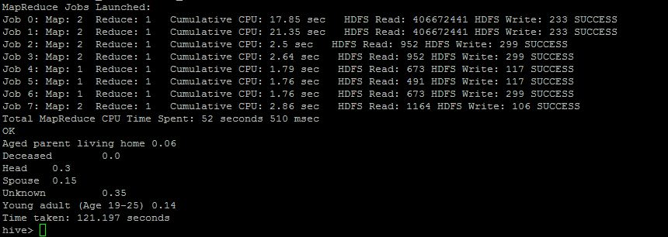

hive> CREATE TABLE 2D as SELECT t1.hhtypedesc, ROUND(t1.hhcount/t2.total, 2) percentoftotal FROM vw_hhcount t1 JOIN (SELECT SUM(hhcount) total FROM vw_hhcount) t2;

**2E. How many known households have children? (use PRESENCE_OF_CHLDRN column)**

hive> SELECT count(*) hhwithchildren FROM emchive WHERE PRESENCE_OF_CHLDRN = 'Y';

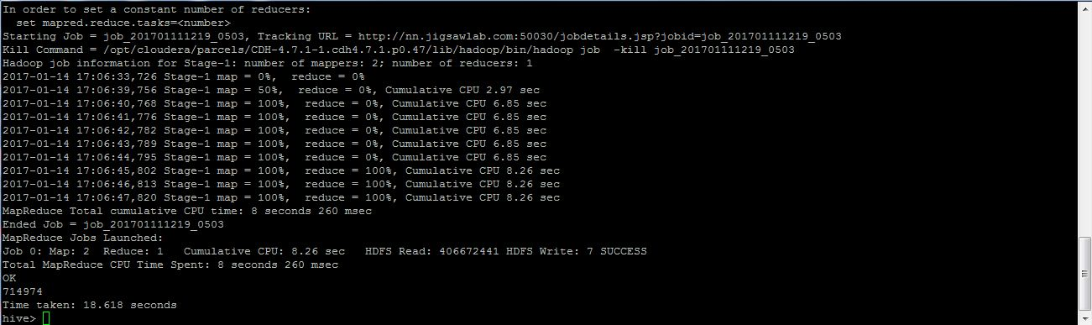

hive> CREATE TABLE 2E as SELECT count(*) hhwithchildren FROM emchive WHERE PRESENCE_OF_CHLDRN = 'Y';

**2F. Overall, how many children are there? (use NUMBER_OF_CHLDRN_18_OR_LESS column and PRESENCE_OF_CHLDRN )**

hive> SELECT SUM(CAST(NUMBER_OF_CHLDRN_18_OR_LESS AS TINYINT)) FROM emchive WHERE PRESENCE_OF_CHLDRN = 'Y';

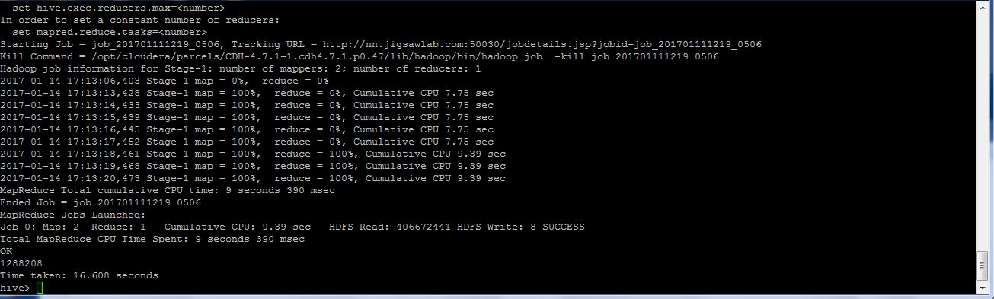

hive> CREATE TABLE 2F as SELECT SUM(CAST(NUMBER_OF_CHLDRN_18_OR_LESS AS TINYINT)) FROM emchive WHERE PRESENCE_OF_CHLDRN = 'Y';

**2G. How many of the children are male and how many are female? (use GNDR_OF_CHLDRN_0_3 - GNDR_OF_CHLDRN_13_18 column)**

hive> SELECT t2.gender, count(1) gendercount FROM emchive t1 LATERAL VIEW explode(array(GNDR_OF_CHLDRN_0_3, GNDR_OF_CHLDRN_4_6, GNDR_OF_CHLDRN_7_9, GNDR_OF_CHLDRN_10_12, GNDR_OF_CHLDRN_13_18)) t2 AS gender WHERE t2.gender='M' OR t2.gender='F' GROUP BY t2.gender;

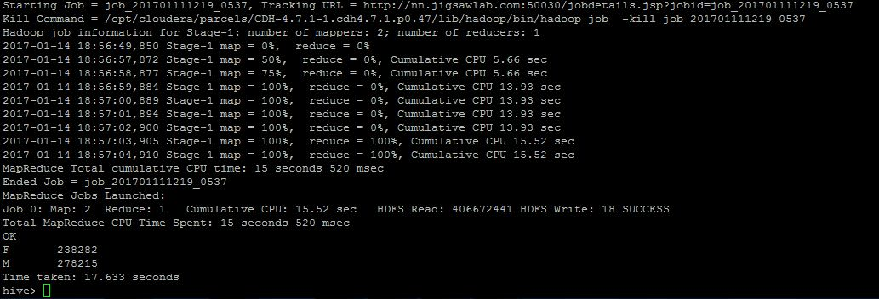

hive> CREATE TABLE 2G AS SELECT t2.gender, count(1) gendercount FROM emchive t1 LATERAL VIEW explode(array(GNDR_OF_CHLDRN_0_3, GNDR_OF_CHLDRN_4_6, GNDR_OF_CHLDRN_7_9, GNDR_OF_CHLDRN_10_12, GNDR_OF_CHLDRN_13_18)) t2 AS gender WHERE t2.gender='M' OR t2.gender='F' GROUP BY t2.gender;

**Tableau**

**Tableau Report for Question1 - CTOR**

**Dashboard 1**

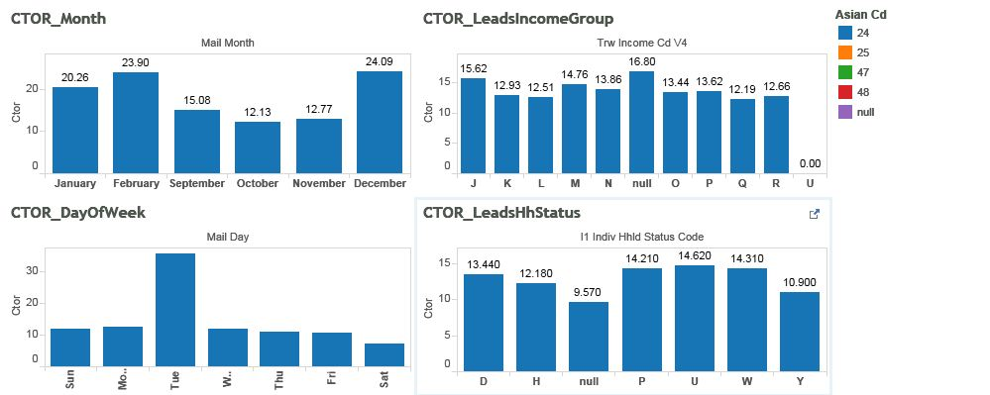 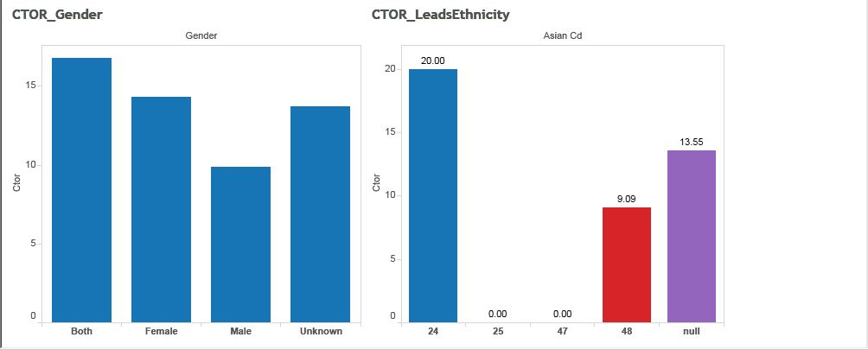

**Dashboard 2**

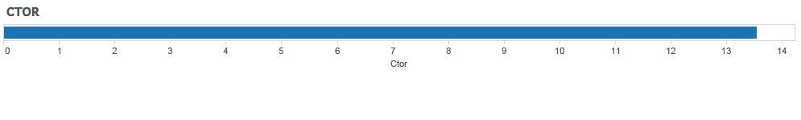

**CTOR_TimeOfDay**

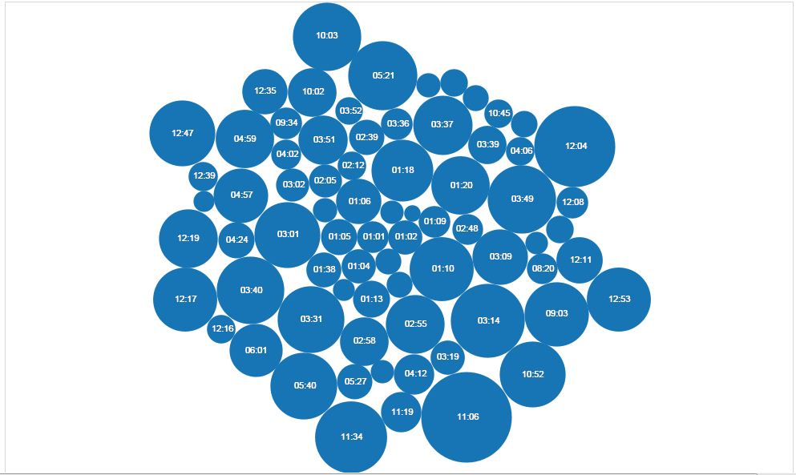

**Tableau Report for Question 2 – Household Member’s Information**

